Elmbridge “e.j.” jones, jr, collection

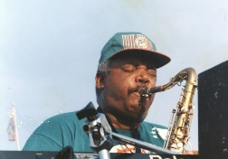

# About this collection

# Preferred name : aaron

# Rahshon stepenson2001 African American Achievers

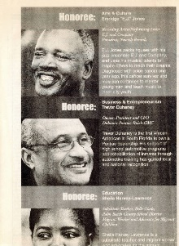

This is the newspaper clipping mentioning the musician

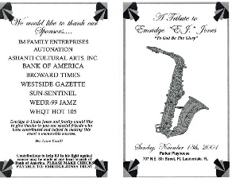

This is a tribute to Elmbridge jones jr.

Photo origin : https://digitalarchives.broward.org/digital/collection/p16146coll9/id/45/rec/47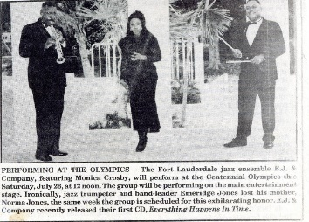

This photo depicts a newspaper clipping advertising Elmbridge performance at the 1996 centenial Olympics featuring monica crosby

# Photo origin :https://digitalarchives.broward.org/digital/collection/p16146coll9/id/45/rec/47

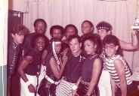This photo has elmbridge in a group photo surrounded by what looks to be friends and family

Photo origins : https://digitalarchives.broward.org/digital/collection/p16146coll9/id/45/rec/47